Choline Chloride as Clay Stabilizer and Shale Inhibitor
For Oil and Natural Gas Drilling Industry

Choline chloride (HETMAC), CAS number: 67-48-1, (chemical name: 2-hydroxy-N, N, N-trimethylethanaminium chloride) is an officially recognized vitamin ingredient for animal feed use, as per 21 CFR Regulation 182.8252. It is a nutritional additive with chemically well-defined substances having similar effect according to 1831/2003/EC. Currently, it is a very popular commercial clay stabilizer and shale inhibitor.

- What is a clay stabilizer?
1.1 Shale and/or clay swelling
In oil and gas drilling and hydraulic fracturing, the shale and/or clay may swell in the presence of water, which may cause a series of major problems including: wellbore instability, cuttings disintegration, bit balling, fines migration. All these issues can result in higher drilling costs, lower well productivity and even destruction to wellbores.
Two mechanisms are responsible for the swelling and migration of clays: surface hydration and osmotic swelling. Surface Hydration shows little visible signs of swelling in normal pressure. However, when the pressure is greater than 60,000 psi, water moisture desorption from clay surface is required. Swelling due to osmotic differences is a bigger problem. This occurs when concentration of ions in the clay at the wellbore wall is higher than that in the drilling fluid. Due to this difference in ion concentrations (this is called Osmotic Pressure), water in the clay moves toward the clay surface, causing swelling. The degree of swelling depends on the concentration of salts in the clay relative to the drilling fluid.
Clay stabilizer or shale inhibitor (also called anti-swelling agents) can reduce and prevent clay swelling and shale erosion. The objective of clay stabilizer is to keep a sufficiently high ion concentration in the fluid.

2.2 Characteristic and mechanism
Generally, clay stabilizer and shale inhibitor, except KCl (potassium chloride), have the same structure of quaternary amines, such as NH₄Cl (ammonium chloride, AC), [(CH₃)₄N]Cl (Tetramethylammonium chloride, TMAC). and certain polymeric amines. Cations and KCl usually function through cation ion exchange. They enter into the crystal lattice of clay, where the cations (NH₄⁺, (CH₃)₄N⁺, K⁺) of clay stabilizer replace the Na⁺ on the surface of clay to prevent swelling. However, the polymeric amines stabilizers just adsorb onto the surface of clay or shale.

2.3 Commercial Clay Stabilizers and Shale Inhibitors
KCl has been the primary choice as a temporary clay stabilizer, but it can be incompatible with other materials. It is only effective in salt-containing drilling fluid/mud. Once fresh water is added, this balance will be broken and the clay will swell once again. In addition, the use of KCl in drilling raises environmental concerns due to its high Cl⁻ content.
TMAC can replace KCl as the clay and shale stabilizer, especially in fracturing fluid. The quantity of TMAC needed is only 1/10 that of KCl. TMAC provides temporary protection because of the single cation, NH₄⁺ . TMAC is very cheap and suitable for short-time operations. The main drawback is its toxicity and odor, although it can be used in the oilfields due to its strong adsorption on the clay, which will reduce its residue content in the drilling fluid.

Table 1 Clay stabilizers summary
Name | Structure | Function/Limitation | Preparation | Feature
Potassium Chloride (KCl) | K⁺Cl⁻ | Bad compatibility, temperature  limitations | On-site preparation | High content of Cl⁻
Ammonium Chloride (AC) | NH₄⁺Cl⁻ | pH and  temperature  limitations | On-site preparation | Obnoxious odor,  toxicity
Tetramethylammonium chloride (TMAC) |  | pH and  temperature  limitations | On-site preparation | Toxicity,  bad odor
Choline Chloride (HETMAC) |  | Good compatibility, ammonia odor,  may be eaten by microorganisms | Ready to use | Bio-degradable, nontoxic

As shown in Table 1, the traditional clay and shale stabilizers have restricted applications due to their limited temperature and pH stability in addition to their strong odors, bad compatibility and lower level of inhibition. They are much more toxic than HETMAC in both onshore and offshore as drilling fluid additives.

- Why choline chloride is the best choice
2.1 Higher efficiency
With the structure of quaternary amines, a typical “cation”, choline chloride can act the same as some traditional clay and shale stabilizers (e.g. KCl, TMAC), but with higher efficiency. According to Figure 1, we can see that at the same level of concentration, choline chloride provides much faster filtration, indicating less swelling of the clay.
Capillary Suction Time (CST) test is a relatively simple test that can be performed on site to test the effectiveness of clay stabilizers. Since CST results can be manipulated using different shear rates and times for sample preparation, data obtained from CST tests are not very reproducible. But we can compare qualitatively the effect of different clay stabilizers. According to Figure 2, we can see that 2ppm choline chloride mud have almost the same performance as 2% KCl mud, meaning much smaller amount of choline chloride is needed for the same effect.

2.2 Good compatibility
It is known to all that many kinds of chemicals are involved in the hydraulic fracturing process. The number is as high as 78 according to reports. Choline chloride has a good compatibility with brine, calcium chloride (CaCl₂), and KCl solutions found in hydraulic fracturing fluids, cross-linkers and breakers.

Figure1: Filtration time test of KCl and Choline Chloride
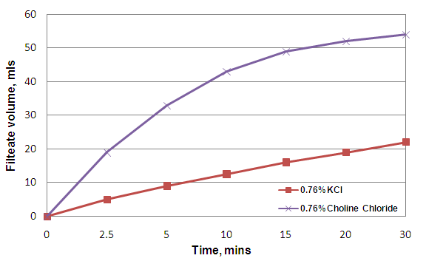
Figure 2: CST test of different clay stabilizer mud
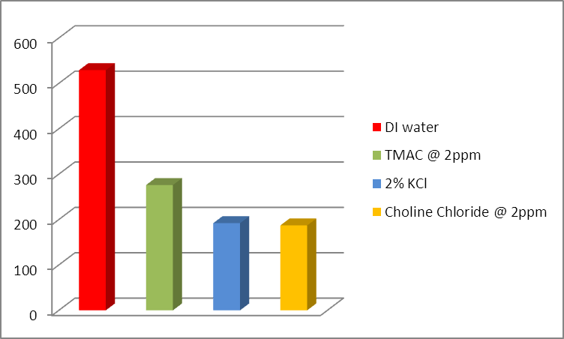
2.3 Safer
Apart from the higher efficiency, the higher safety of choline chloride is also very attractive. The pollution to groundwater caused by chemicals in drilling fluid is now the most controversial topic of the hydraulic fracturing method in shale gas industry in the USA. The low toxicity of choline chloride is exciting.
Choline chloride, the primary non-oilfield use of which as an important nutritional additive in animal feeds, is normally considered as a kind of vitamin B4. As shown in Table 2, choline chloride is the safest chemicals among all the commercial shale inhibitors.
Furthermore, the leakage of chloride ions from drilling fluid to the soil can pollute surface water. However, the residue chloride ions in drilling fluid from choline chloride are reduced by almost up to 75% compared to that from KCl.
Only some chemical residues which is corrosive in nature, should be considered. The most important one is trimethylamine (TMA), which is one of the most important raw materials during choline chloride synthesis. Science Research shows that when the TMA residue is higher than 300ppm, it can cause toxicity. Some manufacturers can’t control the level of TMA residue well with their poor manufacturing process, which causes a strong fishy odor and a light yellow color in their choline chloride liquid. HAVAY, as a leading manufacturer of choline chloride, can promise qaulity choline chloride liquid with a TMA residual lower than 200ppm.

2.4 Readily biodegradable
Choline chloride is also readily biodegradable, according to the Organization of Economic Co-operation and Development (OECD-criteria). MITI-test shows 93% of choline chloride is biodegraded within 14 days. This biodegradation test method measures the biochemical oxygen demand (BOD); a substance could be considered as a readily biodegradable one when 60% of biodegradation occurs within 28 days. This result is confirmed by a BOD test performed in accordance with DIN 38409 part 43(German national biodegradation test), where a 75% biodegradation was obtained.
Table 2: Toxicological information
Chemical Name | Toxicological information
KCl | LD₅₀ - 2600 mg/kg oral (rat)  LD₅₀ - 552 mg/kg intraperitoneal (mouse)
NH₄Cl | LD₅₀ - 1650 mg/kg oral (rat)
TMAC | LD₅₀ - 125 mg/kg oral (rat)  LD₅₀ - 25 mg/kg intraperitoneal (mouse)  LD₅₀ - 40 mg/kg subcutaneous (rat)  LD_{LO} - 1500 mg/kg (rat)  LD_{LO} - 6 mg/kg subcutaneous (rabbit)  LD₅₀ - 6 mg/kg subcutaneous (frog)
Choline Chloride | LD₅₀ - 3400 mg/kg oral (rat)  LD₅₀ - 450 mg/kg intraperitoneal (rat)  LD_{LO} - 735 mg/kg subcutaneous (mouse)  LD₅₀ - 53 mg/kg intravenous (mouse)  LD_{LO} - 5 mg/kg intravenous (dog)  LD_{LO} - 25 mg/kg intravenous (cat)  LD_{LO} - 1100 µg/kg intravenous (rabbit)  LD_{LO} - 1000 mg/kg subcutaneous (rabbit)  LD_{LO} - 1500 mg/kg (frog)
LD₅₀: Lethal Dose for 50%
LD_{LO}: Lethal Dose Low

2.5 Better workability
Choline chloride can be used directly at the work site. This ready-to-use availability eliminates time for pre-mixing and any saltwater disposal costs. Choline chloride has a special advantage, it can keep its high efficiency when used in drilling fluid with high NaCl concentration. Due to this feature, choline chloride has an unmatched advantage when used in drilling fluid of offshore oilfield. It has already been the first choice of clay stabilizer and shale inhibitor in seawater based drilling fluid. Besides, as a highly soluble material, choline chloride retains 75% activity and does not suffer from crystallization issues when used in a brine solution in cold condition. However KCl has a limiting activity of 24% and can crystallize in cold condition, which confines its application to a certain degree.

- HAVAY Choline Chloride Evaluation via Shale Erosion Procedure
  - Test Method and Results
20g Shale was hot rolled in mud for 16 hours at 65~70℃. The shale was weighed before and after hot rolling to determine how well the shale inhibitors performed.
Base Mud Formulation: 350mL tap water; 10ppb Bentonite; 2ppb low viscosity Polyanionic Cellulose; 0.5ppb Xanthan Gum; 1 ppb Lignite.
Shale Inhibitors Mud: 3.5ppb concentration from different brands of choline chloride were added into the base mud formulation to work as shale inhibitor

Figure 3: Shale Erosion test results of different brands of choline chloride
